HOWTO: Email Encryption with Thunderbird
A guide to setting up PGP-encrypted email on Windows and OSX
Purpose: This guide attempts to explain how to implement PGP email encryption to enhance security and privacy. This guide is a recipe, not an encyclopedia. Its primary goal is to demonstrate how it is done, not to explain why (although there is some explanation at the end). For further information, we recommend consulting the Ars Technica article on setting up email encryption, which we have included on this CD along with other information about encryption. The Ars guide uses the same method described below, but we have no affiliation with Ars Technica. The article can be found online: http://arstechnica.com/security/2013/06/encrypted-e-mail-how-much-annoyance-will-you-tolerate-to-keep-the-nsa-away/

Software: The following software is used in this guide. For best security, always download the files from the original source and verify the checksum. For your convenience, we have included the latest version of the software as of the time this guide was written [2013.09.13].
- Mozilla Thunderbird – open-source email client, works similarly to Outlook (https://www.mozilla.org/en-US/thunderbird/)
- GPG Suite (OS X) – open-source PGP key manager for Mac OS X computers
(https://gpgtools.org/)
- Gpg4win (Windows) – open-source PGP key manager for Windows computers
(http://www.gpg4win.org/)
- TrueCrypt (optional) – TrueCrypt is not necessary for email encryption, but it allows you to create encrypted “containers” that work like password-protected folders. You can fill these containers with the files you want to encrypt, and send them as email attachments as one way to encrypt attachments. You can also use them to keep your personal data more secure on your own computer.
(http://www.truecrypt.org/)

Nutshell
First, we are going to install Thunderbird. This will be your new way to access your existing email account (or you can create a new account if you'd like). If you have used an email program like Outlook, you should know what to expect.

Second, we install a PGP key manager. This program will allow you to keep track of your Private Keys and all of your contacts' Public Keys. It will also allow you to create a key pair if you do not have one yet.

Third, we will install Enigmail, an Add-On for Thunderbird that encrypts your emails using your keys. It works sort of like a bridge between Thunderbird and the key manager.

Finally, we test it to make sure it works. I'll also outline how to use TrueCrypt to securely backup your private key and briefly mention a few other relevant topics.

The Appendix has some general information on keys, keysigning, and keyservers, as well as some suggestions for further reading.

Part I: Install Thunderbird

- Obtain the Thunderbird installation file
  - Visit https://www.mozilla.org/en-US/thunderbird/ and download the latest version
  - or, install Thunderbird from the installation file on this CD
- Install Thunderbird
  - Double-click the installation file in your download folder or on the CD
  - OS X – Drag Thunderbird to your Applications folder
  - Windows – Allow the program to run and click Next until the installation program finishes. The standard options are okay.
- Run Thunderbird
  - OS X – Double-click Thunderbird in your Applications folder
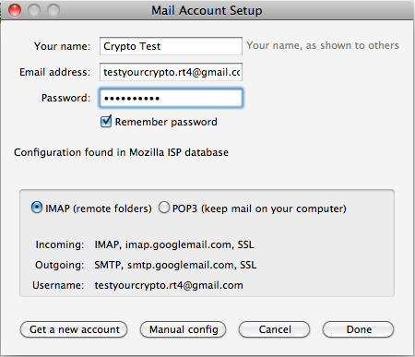
  - Windows – Thunderbird should run after installation. If it does not, click the Start menu, select Programs or “All Programs”, and click Mozilla Thunderbird.

- Configure Thunderbird to use your current email account
  - Thunderbird should automatically begin to setup your email account. If it does not, click “Create a new account”
    - Click “Skip this and use my existing email” to setup Thunderbird using an email account you already have
    - Type your display name, current email address, and your email password and click “Continue”
    - If you typed your information correctly, you will now have the option to select between IMAP and POP3. Select IMAP if it is not already selected, and press “Done”. Your emails should begin to load. [Note: POP3 will work, but it may require additional configuration not covered in this guide.]
- Done! You can now access your email account using Thunderbird. You may want to customize the appearance of Thunderbird or enable other Add-Ons, but those topics are not covered in this guide. It may take some time to load all of your emails, but you should be able to continue with this guide in the meantime.

Part II: Install GPGSuite or Gpg4win (GPA), and Create Your Key Pair
OS X (GPG Suite)
- Obtain the GPG Suite installation file
  - Visit https://gpgtools.org/ and download GPG Suite
  - or, install GPG Suite from the installation file on the CD
- Install GPG Suite
  - Double-click GPG Suite – 2013.08.06.dmg in your download folder or on the CD.
  - Double-click Install.pkg
  - Click Continue until the installation completes. The default options are okay.

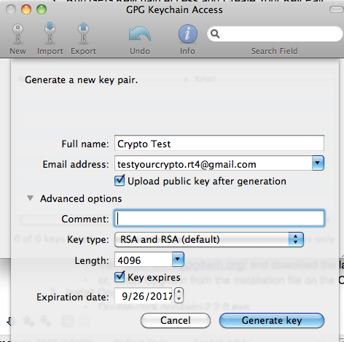

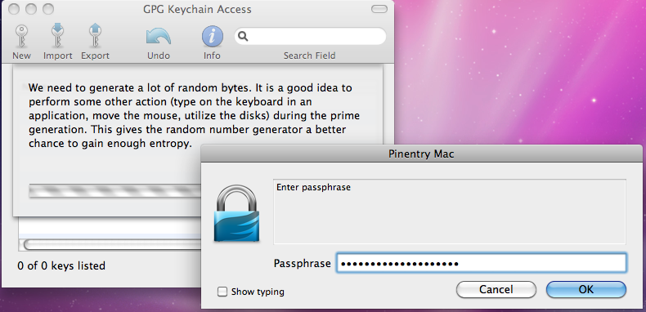
- Run GPG Keychain Access and Create Your Key Pair
  - Double-click GPG Keychain Access in your Applications folders
  - Click New to create a key pair. Enter your name and the email address you want to use with encryption. You can select from the advanced options if you would like to increase security by making your key longer or having it expire.
  - When the you see the prompt that says “Enter passphrase”, wait for a second. Read the text in the box that's probably hidden behind the passphrase box. It basically says to do some stuff on your computer like copy large files and type some things for a bit to make your key more random. (The more random it is, the harder it is to crack.)
  - Then, type a passphrase and press OK. You will use this passphrase to access your private key when you need to send an email or decrypt an email sent to you. It should be as long and complex as you can possibly tolerate typing on a regular basis.
  - Done! You now have a key pair; a Public PGP Key and a Private PGP Key. Do you know what that means? If you don't, now is a good time to go read the Appendix.

Windows (Gpg4win with GPA)
- Obtain the Gpg4win installation file
  - Visit http://www.gpg4win.org/ and download the latest version
  - or, install Gpg4win from the installation file on the CD
- Install Gpg4win
  - Double-click gpg4win-2.2.0.exe
  - Click next until you reach the “Choose Components” page. Check the box next to GPA (GNU Privacy Assistant)
  - Click next until the installation completes. Default options are okay. Uncheck the box next to View README and click “Finish”.
- Run GPA and Create your Key Pair
  - IMPORTANT: See Appendix for general information about key pairs and how the whole process works. This won't make much sense otherwise.
  - Click Start, then Programs, then Gpg4win, and run GPA. This is your key manager program.
  - GPA should prompt you to create a key the first time you run it, if you do not see the prompt, you can create a key by clicking the “Keys” menu, then “New Key...”, or by pressing Control + N.
  - Enter your name and the email address you will be using with this key. Create a backup copy later, unless you already have a safe location to store it. Storing private keys can be one use for TrueCrypt, see Appendix for more information.
  - Enter a password. This is what you will type whenever you want to encrypt or sign a message you are sending, or when you want to decrypt a message sent to you. You should now see your key on the list in the GPA window.
  - [Optional] Now that you have created this key, it is a good time to upload your public key to the keyserver. You can do this by clicking the key you created, then the “Server” menu, then “Send Keys...”. For more information on why keyservers are used, see Appendix.
- Done! You now have a key pair; a Public PGP Key and a Private PGP Key. Do you know what that means? If you don't, now is a good time to go read the Appendix.

Part III: Install Enigmail
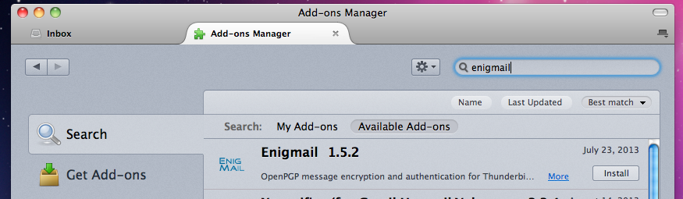
- Run Thunderbird, if it is not still open.
- Open “Add-Ons”, located in the “Tools” menu or in the menu launched by the button with 3 horizontal bars near the top right of Thunderbird.
- Search for Enigmail using the search box on the Add-Ons page. Click install, and then restart Thunderbird to enable the add-on.
- WINDOWS ONLY: check Enigmail In the “Tools” menu or button, select OpenPGP >> Preferences. If you see an error message, or if the Preferences box shows “Could not find GnuPG” under “Basic Settings” and “Files and Directories”, check the box “Override with”. Then, press “Browse...”. Navigate to and select “C:\Program Files\GNU\GnuPG\gpg2.exe”. (On some systems, you may need to use “C:\Program Files (x86)\GNU\GnuPG\gpg2.exe”.)
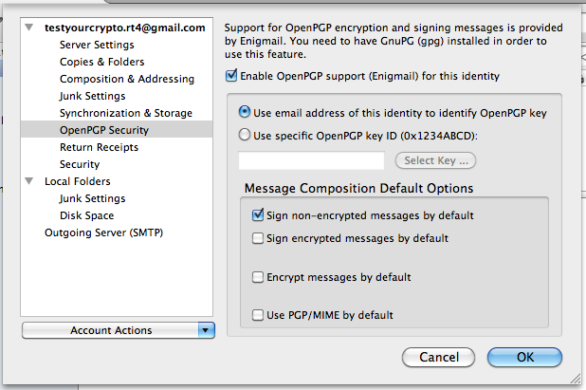
- Configure Enigmail for your email account. Click the menu button and go to “Options” or “Preferences” and then “Account Settings”. On the left side, select OpenPGP Security. Check the box at the top of the right side to enable Enigmail. If you entered your email address when you made your private key, the “Use email address of this identity...” option is fine. Otherwise, click the specific key option and press “Select Key”. Select the key you made and press OK.
- Done! You can now send and received encrypted emails.

Part IV: Send and Receive a test email

Basics of Keys: In order to send someone an encrypted message, you will need their public key. For example, to send a message that only John can decrypt, you must encrypt it with John's public key. John then uses his private key to decrypt the message. Never give out your private key for any reason. Whoever has your private key can decrypt any encrypted message sent to you using your paired public key. For further information on how key pairs work, now is a really good time to read the Appendix or see the suggested links on that.

1. Obtain a public key from someone you want to email. This CD contains the public key for the email address testyourcrypto.rt4@gmail.com. If you don't have anyone's public key, try that one and be sure to send me your public key so I can respond. I'll try to answer you ASAP by sending you an encrypted email back. Please do not send any sensitive information. This is for testing purposes only, and you cannot be sure that the public key on this disc was not tampered with.

2. Import the recipient's public key
Windows - find the key file and right click it. Click “More GpgEX Options” and then “Import Keys”. If this option is not available or does not work, open up GPA and click Import. Find the file and select it. Click OK.

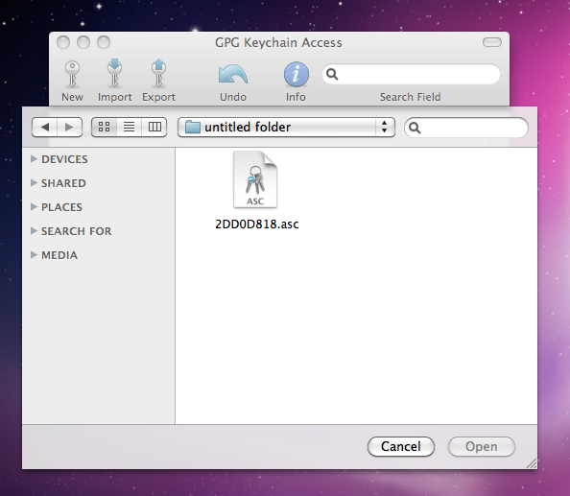
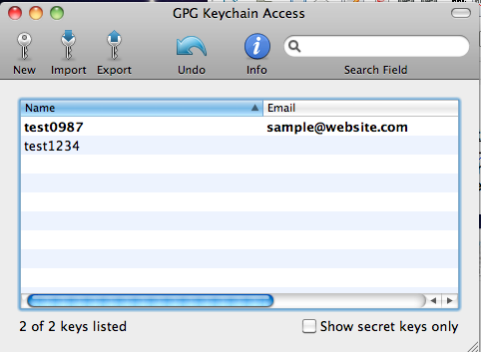

OS X – open up GPG Keychain Access and click Import. Find and select the key file, then Click Open.

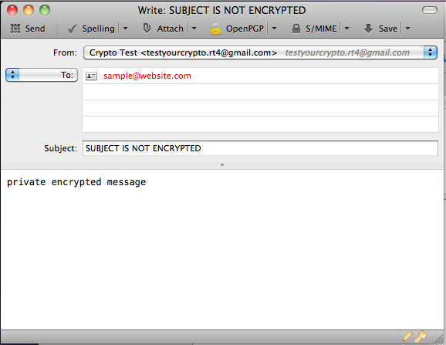

3. Type a test email. Open Thunderbird and address an email to the owner of a public key you imported. Type something in the body to be encrypted. Please note that the subject line will not be encrypted.

4. Encrypt and send the message. Press the key icon in the bottom right of the Compose window, or select “Encrypt this message” under the OpenPGP menu. Press Send to send the email. You should see your message turn into what looks like garbage text right before it gets sent out. It may ask you to enter the passphrase for your private key. If so, type the passphrase you typed when you created the key pair.

Note: It also may give you a warning about HTML. To avoid possible problems, I recommend using only plain text for encrypted messages. To compose in plain text, hold shift when you press the Write or Reply button. You can turn off HTML by default in Tools > Account Settings. Select “Composition & Addressing” on the left, and uncheck the first box on the right, “Compose messages in HTML format”.

5. That's it, you've sent an encrypted message! If you sent it to testyourcrypto.rt4@gmail.com, I will send you a reply as soon as I can letting you know if it worked. If you send me your public key as a file or in the text of your email, I will send you an encrypted response.

Receiving Encrypted Messages: When you receive an encrypted message, just click it. A box will pop up asking for your passphrase. Enter it and the message should now be decrypted.

Appendix
- How do key pairs work?
Imagine you are in a room full of people. Maybe a party, like...a CryptoParty. Each person has a box with two locks on it, and each lock uses a different key. Opening the top lock will allow someone to slip a message into the box. Opening the bottom lock will allow you to take messages out to read them. Since you want all of your new friends to be able to drop a message in your box, you make copies of the key to the top lock for everyone. So anyone with your top key can drop in a note, but only you have the bottom key to take the notes out.

As you may have guessed, the above example is a lot like how our key pairs function. The key you copied and gave out to everyone is like your Public Key. Someone can use your Public Key to encrypt a message so that it can only be decrypted with your Private Key. So as long as you don't give your Private Key to anyone else, only you can decrypt the message.

- What is keysigning, and why does it matter? What is a keyserver?
Imagine you have a passport. When you travel internationally, customs will inspect and stamp your passport. The stamp shows a date, as well as the name of the agency doing the stamping and other information. So, if you could be sure the stamps were real, you could prove your passport was inspected by others and they found it to be real and to belong to you.

The passport in the example is like your public key, except you don't have to travel internationally to get it stamped, and you have ways to ensure the stamps are real. Keysigning is the act of verifying that a public key belongs to the person it claims to and then “stamping” it with the signature of the person who verified it. Signing someone's key essentially attests: “I have verified that this key belongs to its purported owner, and it could not have possibly been modified by a third party.” Now, a third party who trusts the person who did the signing can trust the public key that was signed.

Suppose Abe goes to a keysigning party and gives Brian his public key. Brian and Abe have known each other for a while, and Abe gave Brian the key on a flash drive, in person. Since Brian is confident that the key came from Abe and it couldn't have been tampered with in transit, Brian signs Abe's key. Suppose later on, Brian's sister Carmen wants to send Abe an encrypted love message. Carmen couldn't make it to the party, so she just gets a copy of Abe's public key from her brother. Since she wants to be sure that only Abe can read the message, she checks the signatures on Abe's public key. She sees that her brother Brian signed it, and so did her best friend Danelle, as well as a few other friends she can trust. Since she trusts the signatures, she can trust that the message really will be encrypted so only Abe can decrypt it.

Now how do you make sure people can see all of the signatures on your key? If you gave them a copy of your “passport” before it had all the “stamps” in it, what good does it do? You have two options. The first is to manually give out the latest copies of the public key with all the signatures to everyone you already gave your key to. But with the magic of the Internet, you can use a keyserver to keep the latest copy online for your contacts to download. That everyone can get the latest version easily, and people who contact you for the first time can have an idea of how much to trust the key.

The following link contains a lot more information on keysigning and trust networks:
http://www.cryptnet.net/fdp/crypto/keysigning_party/en/keysigning_party.html#overview

- How do I use Truecrypt? Why?
Sorry I didn't have time to write this section. TrueCrypt has a good guide on their website (http://www.truecrypt.org/docs/tutorial). Basically just follow that guide to make a TrueCrypt container and use that to store a backup of your private key on a flash drive in a safe place. That way your backup copy is safely encrypted in case it gets in the wrong hands.

- Suggested links for further information
Restore the Fourth Wiki – more information, as well as the latest version of this guide
[http://r4wiki.com]

Ars Technica Email Encryption Guide – same setup, different guide
[http://arstechnica.com/security/2013/06/encrypted-e-mail-how-much-annoyance-will-you-tolerate-to-keep-the-nsa-away/]

Keysigning Party HOWTO – intro to keysigning, keyservers, and webs of trust
[http://www.cryptnet.net/fdp/crypto/keysigning_party/en/keysigning_party.html]

TrueCrypt Tutorial – how to get started with TrueCrypt
[http://www.truecrypt.org/docs/tutorial]

Email encryption using Mutt – alternate method
[http://codesorcery.net/old/mutt/mutt-gnupg-howto]

- List of included documents and software on CD
- Software: Thunderbird, Enigmail, gpg4win, GPGSuite, TrueCrypt.
- Documents
    - PDF documents of the suggested links
    - GNU General Public License

- Copyleft notice
This document is covered under GNU General Public License. The applications included on this CD are open-source and can be obtained at the creators' websites, listed above. (Please consult application documentation for their specific licenses.)

If you find problems with this guide, need help, or have improvements or suggestions, please contribute to the wiki [rt4wiki.com] or email me at testyourcrypto.rt4@gmail.com.

